PROJECT REPORT

ON

LOGIN SYSTEM

SUBMITTED BY :-

RAJAT DOGRA -- 20CS29

SACHIN THAKUR –20CS04

BSC(C.S) ---- 2ND YEAR

SUBMITTED TO :- ABHINAV SHARMA

INDEX

INTRODUCTION

SCOPE OF THE PROJECT LOGIN SYSTEM

SOFTWARE REQUIREMENT SPECIFICATION

DIAGRAM OF LOGIN SYSTEM

CONCLUSION OF THE PROJECT LOGIN SYSTEM

INTRODUCTION

The “Login System” has been developed to override the problem prevailing in the practicing manual system. The software is supported to eliminate and in some cases reduce the hardships faced by this existing system. Moreover this system is designed for the particular need of the company to carry out operations in a smooth and effective manner.

Every organization, whether big or small, has challenges to overcome and managing the information of Password, Username, Register, Change Password, Programmer. Every Login System has different Username needs, therefore we design exclusive employee management system that are adapted to your managerial requirements. This is designed to assist in strategic planning, and will help you ensure that your organization is equipped with the right level of information and details for your future goals. Also, for those busy executive who are always on the go, our system comes with remote access features, which will allow you to manage your workforce anytime, at all times. These systems will ultimately allow you to better manage resources.

Scope of the Project Login System

It may help collecting perfect management in details. In a very short time, the collection will be obvious , simple and sensible. It will help a person to know the management of passed year perfectly and vividly. It also helps in current all works relative to Login System . it will be also reduced the cost of collecting the management &collection produce will go on smoothly.

Our project aims to business process automation, i.e we have tried to computerize various processes of login system

* In computer system the person has to fill the various forms & number of copies of the forms can be easily generated at a time .
* In computer system , it is not necessary to create the manifest but we can directly print it , which save our time .
* To assist the staff in capturing the effort spent on their respective working areas .
* To utilize resources in an efficient manner by increasing their productivily through automation .
* The system generates type of information that can be used for various purpose.
* It satisfy the user requirement.
* Be easy to understand by the user and operator.
* Be easy operate
* Have a good user interface.
* Be expandable.
* Delivered on schedule within the budget.

Software Requirement Specification

The Software Requirement Specification is produced at the culmination of the analysis task. The function and performance allocated to software as part of system engineering are refined by establishing a complete information description, a detailed functional and behaviour all description , an indication of performance requirements and design constraints , appropriate validation criteria, and other data pertinent to requirements.

The proposed system has the following requirements :-

* System needs store information about new entry of username.
* System needs to help the internal staff to keep information of Password and find them as per various queries.
* System need to maintain quality record.
* System need to keep the record of login.
* System need to update and delete the record.
* System also need a search area.
* It also needs a security to prevent data.

Diagram of login system

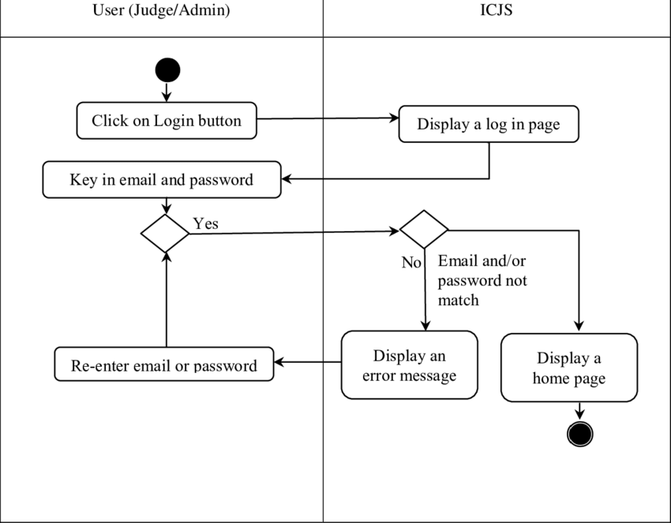

Conclusion of the Project Login System

Our project is a only a humble venture to satisfy the need the manage their project work. Several user friendly coding have also adopted. This package shall prove to be a powerful package in satisfying all the requirements of the school. The objective of software planning is to provide a frame work that enables made within a limited time frame at the beginning of the software project and should be updated regularly as the project progresses.